Feb. 7, 2025

Jonathan Mirin and Godelieve Richard

224 Avery Brook Rd.

Shelburne Falls, MA 01370

Dear Selectboard,

We understand you will be continuing to digest the concerns of various stakeholders on Monday evening and then likely proceeding to a vote. Given the various complexities, we have taken the liberty of responding below to National Grid's response to community concerns received yesterday, two working days before the hearing. You will quickly realize if you look at the list of questions you prepared and their response, there are many questions that remain unanswered.

* + - *The closest National Grid crews that can install and maintain underground assets are in Worcester MA. In the case of an event, the distance the crews must travel will greatly increase any outage durations the residents of Charlemont will*

*experience.*

While this is true, underground lines generally will not need repair following our increasingly frequent storm events. As National Grid continues to bury lines in our forested area, they would no doubt consider moving a team closer.

* + - *Additionally, most of the properties on Avery Brook Rd currently have overhead service. Any underground service from the transformer to the house is customer owned; therefore, if National Grid were to convert this area to underground, all affected customers would be required to contract a private electrician and incur any costs related to a new underground service.*

The offset of not losing property value would make us more than happy to pay those costs in exchange for buried power lines without the potential for wireless installations by National Grid and Verizon.

* + *Property Values*
    - *National grid is not aware of any evidence of distribution lines or EMF impacting property values.*

This page sites various studies about powerlines and EMF impacting property values in addition to the letter we have already submitted from a local realtor: <https://ehtrust.org/cell-phone-towers-lower-property-values-documentation-research/>

# *Non-Project National Grid Concerns*

*1. Wireless Infrastructure*

*o There were questions asked regarding wireless equipment, including data collection,*

*technical specifications, etc. There is no wireless equipment being installed as part of this project and no switches being installed on poles near 224 Avery Brook Rd.*

This is our most significant concern and the subject of our disability request for acomodation that has been vetted and supported by your Board of Health.

This answer is technically correct but essentially a half-truth. "This project" for National Grid means the installation of the larger poles. They are parsing out the installation of wireless infrastructure as a second, later project. However this pole hearing is the only time any local board will have the authority to set conditions, including using fiber in perpetuity on the poles which are next to our home which was built yards from the road when Avery Brook Road was dirt. Robert Ide, Charlemont's National Grid representative, said at the Heath Pole Hearing in December: "This [project] is the beginning of the Smart Grid." He went on to explain that the image below was not how Charlemont and Heath's poles would be outfitted with antennas. Rather there will be "one [antenna] on top." Similarly, a National Grid representative who replaced our EMF-emitting meter (not technically a "smart meter, yet) with an analog meter for which we pay $26/month informed us about a year ago that all of our poles would have antennas on them once smart meters were installed in Charlemont.

Here is National Grid's own page about the rollout: <https://www.nationalgridus.com/Smart-Meter>

Here is a news article about the protest against the "smart meter pilot" National Grid conducted in Worcester: <http://www.golocalworcester.com/news/residents-protesting-smart-grid-pilot-in-worcester/>

Image shared (and corrected by Robert Ide as described above) at the Heath Pole Hearing:

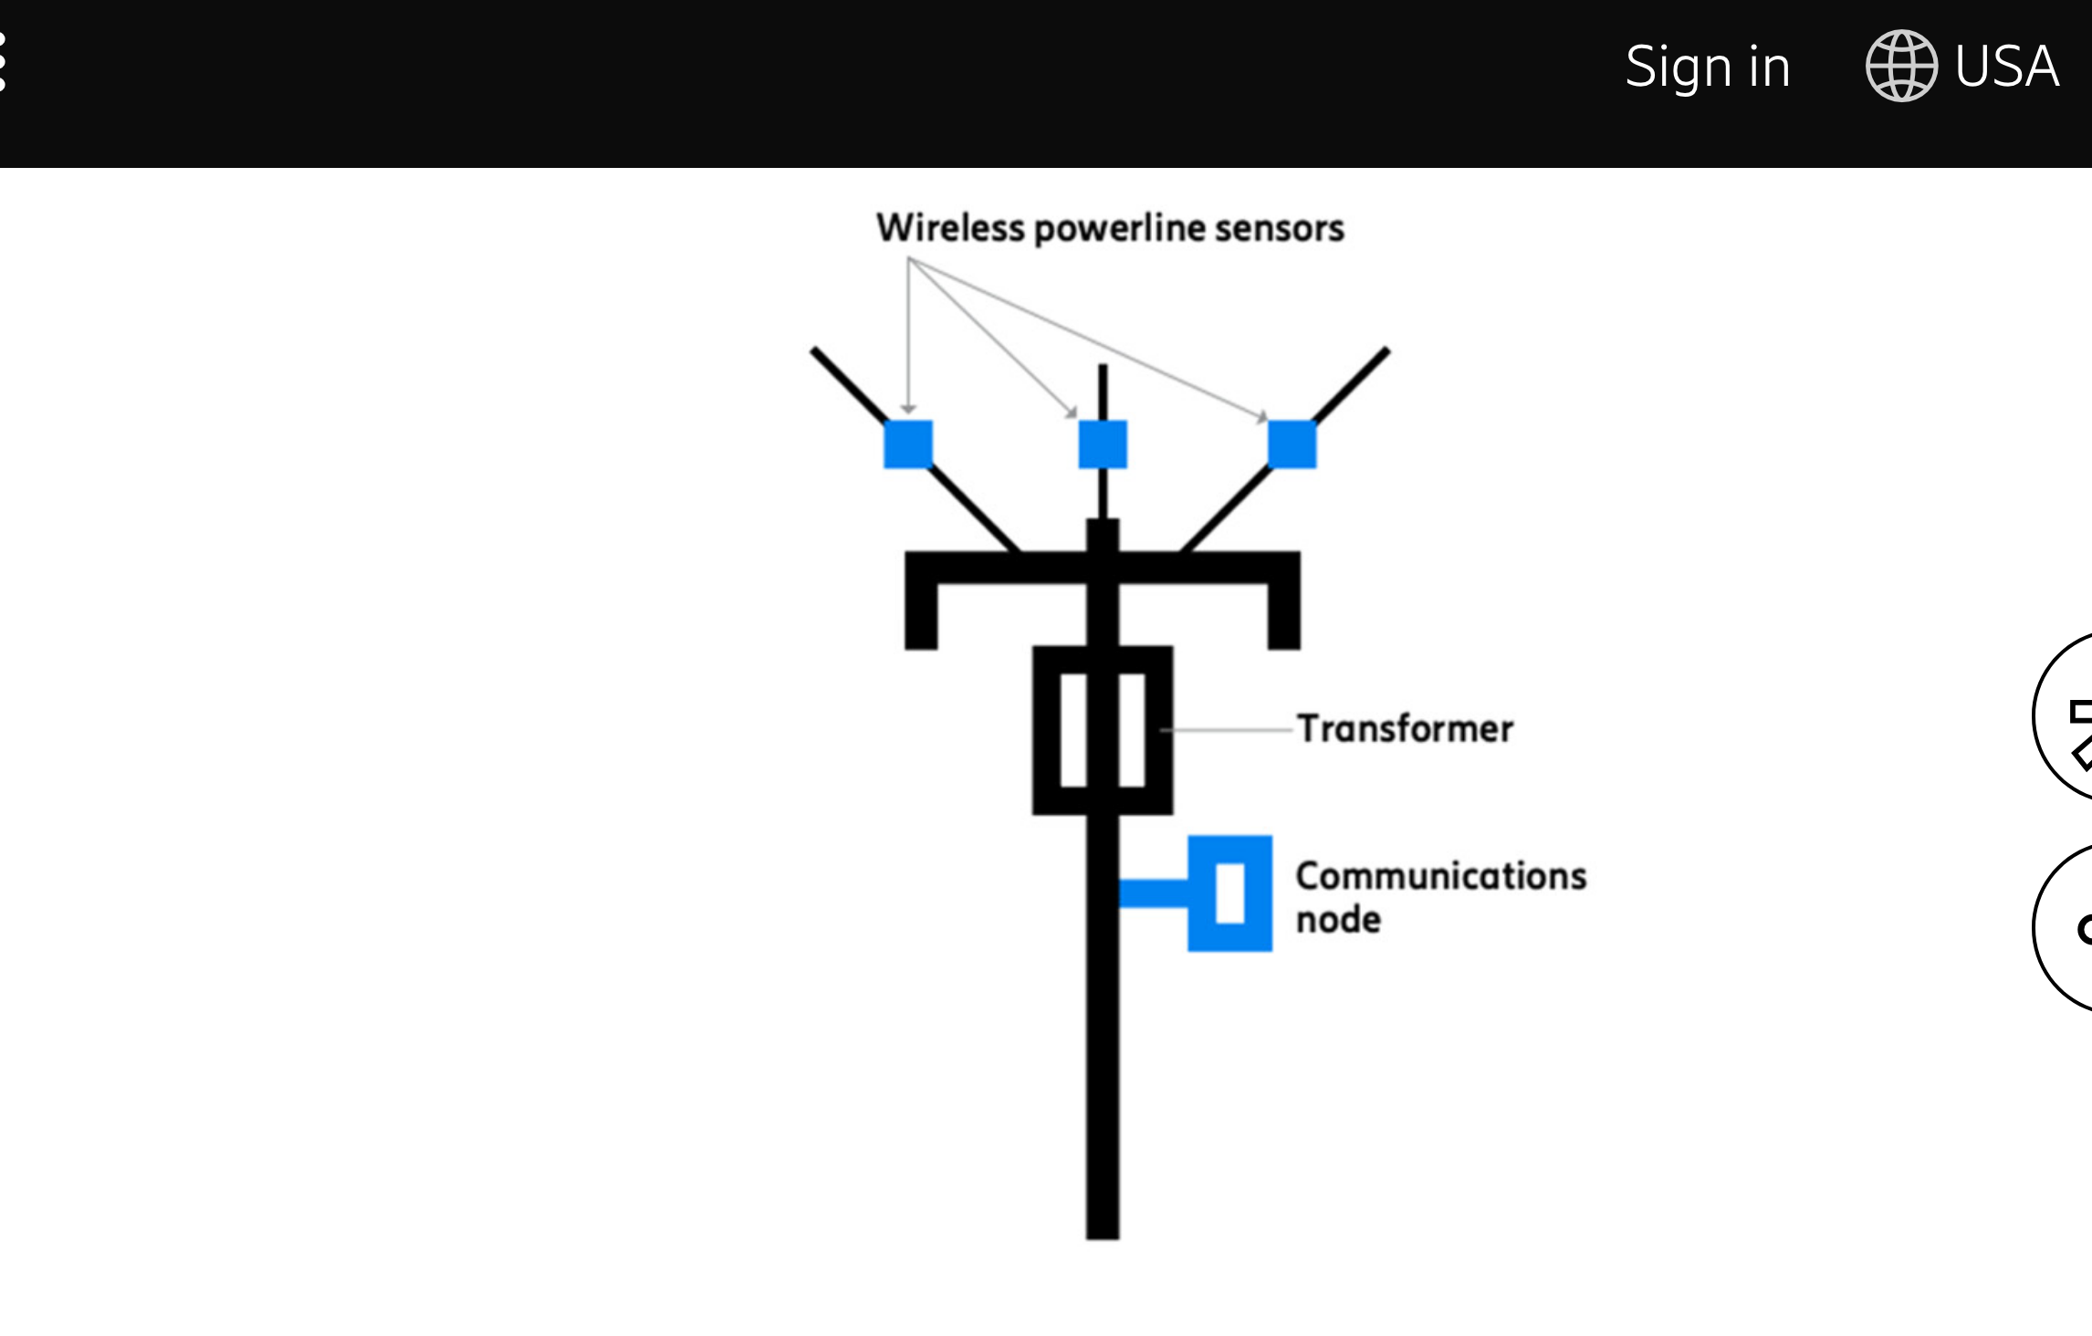

Attached please also find the slides presented by Kent Chamberlin, PhD to the Board of Health. Although Dr. Chamberlin is not able to travel to MA for the hearing on Monday, if you are interested, here is video of him presenting on the subject of EMF harm to the Royal Academy of Medicine: insert link

And if you are interested in learning more about the smart grid and smart meters, the award winning documentary Take Back Your Power is an excellent place to start: add link

As you likely remember, Charlemont residents voted for a [one year moratorium](https://www.hilltownhealth.org/smart-meters-in-ma/) on smart meters at the last town meeting. Unfortunately, this has been deemed a non-binding resolution by the Attorney General. Consequently, you are the last buffer standing between a future where residents who can not afford a monthly fee and those living in multi-family units where meters may be placed next to a child's bedroom, being harmed every day by a meter, [increased fire risk](https://www.hilltownhealth.org/wp-content/uploads/2024/04/Fires-and-Smart-Meters.pdf), increased [hacking](https://texasenergyreport.com/news/2021/06/25/hacking-into-your-smart-meter-theres-a-lot-you-may-not-know/) risk and increased surveillance which of course are the subjects of numerous lawsuits in states around the country dealing with the aftermath of this installation.

All the smart grid benefits can be obtained through National Grid's fiber network (they will not share our municipal fiber due to security concerns) as has been demonstrated in Chatanooga, TN: <https://www.wired.com/2011/01/internet-meets-smart-grid/>

Let's give families another reason to move to Charlemont - no need to pay the opt out fee, your home is safe as is.

Thank you for considering our request.

Sincerely,

Jonathan Mirin and Godelieve Richard